**LAB 1**

**1.Write a Java program to print "Hello, World!" to the console.**

**package** Session;

**public** **class** Hello {

**public** **static** **void** main(String[] args) {

System.***out***.println("HELLO IN JAVA WORLD");

}

}

**Output :-**

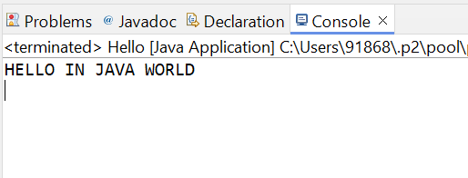

**2.Write a program to find the sum of two numbers entered by the user.**

**package** Session;

**import** java.util.Scanner;

**public** **class** TwoNumber {

**public** **static** **void** main(String[] args) {

Scanner s=**new** Scanner(System.***in***); // use to take user Input;

System.***out***.println("enter the first number");

**int** num1= s.nextInt();

System.***out***.println("enter the second number");

**int** num2= s.nextInt();

**int** sum= num1 + num2; // adding and storing the value in sum variable

System.***out***.println(sum);

s.close();

}

}

**Output :-**

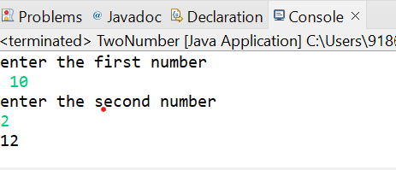

**3.Write a Java program to check whether a given number is even or odd.**

**package** Session;

**import** java.util.Scanner;

**public** **class** EvenOdd {

**public** **static** **void** main(String[] args) {

Scanner s=**new** Scanner(System.***in***);

System.***out***.println("enter the number");

**int** num= s.nextInt();// storing the number in num variable

**if** (num % 2 == 0) //whether number is divided by 2 and remainder is 0

{

System.***out***.println("the number " + num + " is even ");

}

**else**

{

System.***out***.println("the number " + num + " is odd ");

}

s.close();

}

}

**Output :-**

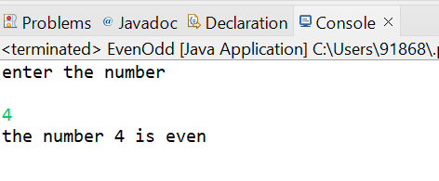

**4.Write a java program to find greatest of 3 numbers.**

**package** Session;

**import** java.util.Scanner;

**public** **class** Greatest3 {

**public** **static** **void** main(String[] args) {

Scanner s=**new** Scanner(System.***in***);

System.***out***.println("enter the number 1");

**int** num1 = s.nextInt(); // taking input 1

System.***out***.println("enter the number 2");

**int** num2 = s.nextInt(); // taking input 2

System.***out***.println("enter the number 3");

**int** num3 = s.nextInt(); // taking input 3

**if** (num1==num2 && num2== num3) // if all numbers are same it will print all are same

{

System.***out***.println("all numbers are same");

}

// using relational and logical operator

**else** **if** (num1>=num2 && num1 >= num3) //check whether num1 is greater than num2 and num3

{

System.***out***.println(num1 + "is greatest");

}

**else** **if**(num2>=num1 && num2 >= num3) //check whether num3 is greater than num1 and num3

{

System.***out***.println(num2 + "is greatest");

}

**else**

{

System.***out***.println(num3 + "is greatest");// else print num3 is greater

}

s.close();

}

}

**Output :-**

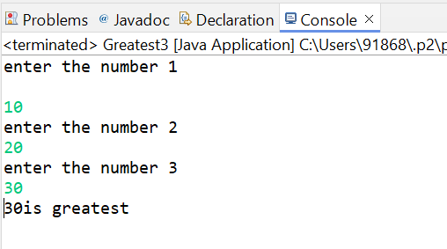

**5.Write a program to implement a basic calculator that takes input and evaluates it.**

**package** Session;

**import** java.util.Scanner;

**public** **class** Calculator {

**public** **static** **void** main(String[] args) {

Scanner s=**new** Scanner(System.***in***);

System.***out***.println("enter the first number");//taking number as input

**int** num1 = s.nextInt();

System.***out***.println("enter the second number");

**int** num2 = s.nextInt();

System.***out***.println("choose the option to perform");// choosing option to perform operation

System.***out***.println("1 Addition");

System.***out***.println("2 Substraction");

System.***out***.println("3 Multiply");

System.***out***.println("4 Divide");

**int** choice = s.nextInt(); //storing the option in choice variable

**if** (choice<1 || choice>4) // using logical operator to check condition

{

System.***out***.println("please enter valid number");

}

**else** **if** (choice==1) // check the entered input

{

**int** sum = num1 + num2;

System.***out***.println("The addition of " + num1 +" and " + num2 + " is " + sum );

}

**else** **if** (choice==2)

{

**int** sub = num1 - num2;

System.***out***.println("The Substraction of " + num1 +" and " + num2 + " is " + sub );

}

**else** **if** (choice==3)

{

**int** Mul = num1 * num2;

System.***out***.println("The Multiplication of " + num1 +" and " + num2 + " is " + Mul );

}

**else** **if** (choice==4)

{

**if**(num2 != 0)// execute the else part if num2 is = 0

{

**int** div = num1 / num2;

System.***out***.println("The Division of " + num1 +" and " + num2 + " is " + div );

}

**else**

{

System.***out***.println("Division by zero not allowed");

}

}

s.close();

}

}

**Output :-**

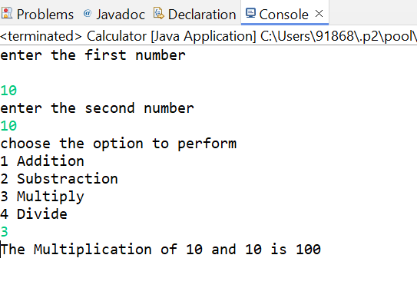

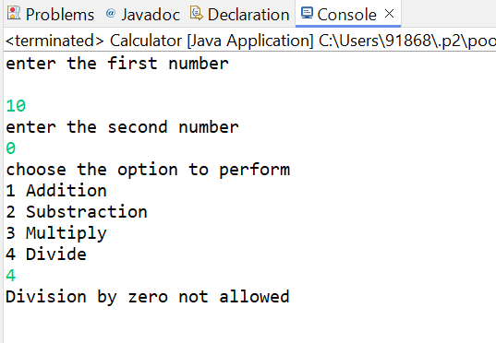

**6.Write a Java program to check if a given number is prime or not.**

**package** Session;

**import** java.util.Scanner;

**public** **class** PrimeNumber {

**public** **static** **void** main(String[] args) {

Scanner s = **new** Scanner(System.***in***);

System.***out***.println("Enter a number to check prime number");

**int** num = s.nextInt();

**int** count = 0;

**if**(num == 2) // to check prime number

{

System.***out***.println(num + " is a prime number");

} **else** {

**for**(**int** i = 1; i <= num; i++) // checking number of factors

{

**if**(num % i == 0)

{

count++;

}

}

**if**(count == 2) // checking number of counts to print result

{

System.***out***.println(num + " is a prime number");

}

**else**

{

System.***out***.println(num + " is not a prime number");

}

}

}

}

**Output :-**

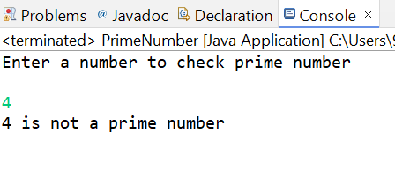 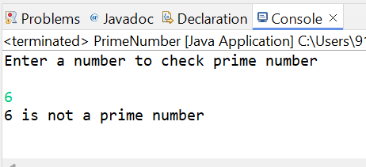

**7.Create a Java program that compares two numbers and prints the larger one.**

**package** Session;

**import** java.util.Scanner;

**public** **class** Greatest2 {

**public** **static** **void** main(String[] args) {

Scanner s=**new** Scanner(System.***in***);

System.***out***.println("enter the number1");

**int** num1 = s.nextInt();

System.***out***.println("enter the number2");

**int** num2 = s.nextInt();

System.***out***.println("choose the method through which u want output");

System.***out***.println("1.ternary method");

System.***out***.println("2.if else method");

**int** method = s.nextInt();

**int** greater;

**if** (num1==num2)// check whether number are same or not

{

System.***out***.println("numbers are same, no greater number found ");

}

**else** **if** (method==1)

{

greater = (num1 > num2 )? num1 : num2 ; // store the larger value in greater variable

System.***out***.println("the greater number between " + num1 + " and " + num2 + " is " + greater);

}

**else** **if** (method==2)

{

**if** (num1 > num2) // compare the numbers

{

greater = num1;

} **else**

{

greater = num2;

}

System.***out***.println("the greater number between " + num1 + " and " + num2 + " is " + greater);

}

**else**

{

//if input is not valid it will give output using ternary operator

System.***out***.println("invalid input.using the default ternary operator to print result");

greater = (num1 > num2 )? num1 : num2 ;

System.***out***.println("the greater number between " + num1 + " and " + num2 + " is " + greater);

}

s.close();

}

}

**Output :-**

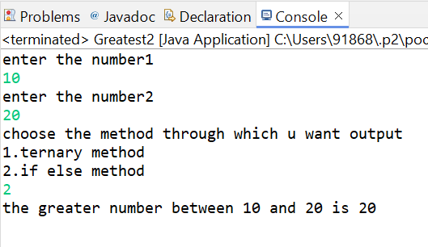

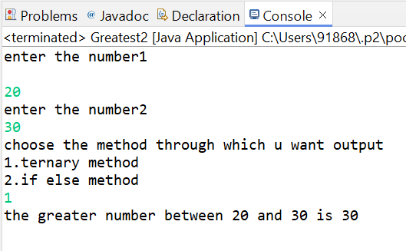

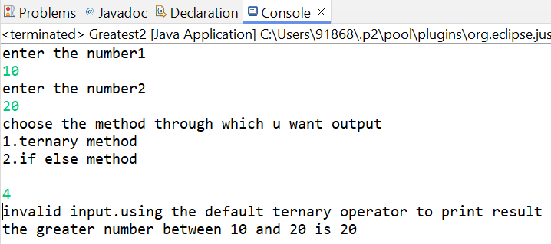

**8.Write a Java program that takes an age input from the user and determines if they are eligible to vote (considering the legal voting age).**

**package** Session;

**import** java.util.Scanner;

**public** **class** VotingAge {

**public** **static** **void** main(String[] args) {

Scanner s=**new** Scanner(System.***in***);

System.***out***.println("enter your age");

**double** age= s.nextDouble();

**int** voteage=18;// legal voting age

**if** (age >= voteage) // comparing age is greater than or equal to voteage or not

{

System.***out***.println("You are eligible for voting ");

}

**else**{

**double** wait=voteage-age;

System.***out***.println("You are not eligible for voting");

System.***out***.println("You can Vote after " + wait + " years");

//print the years that after how many year you are eligible

}

s.close();

}

}

**Output :-**

